Smart Flow Meter

### 

Components required:

Connection Diagram:

Code:

Output:

Interfacing the microcontroller and Mobile App

References:

### 

### Components required:

* 1x RaspberryPi PicoW (Wireless pico)
* 1x Water Flow Sensor: YF-S201 (Hall Effect Sensor)
* 1x Breadboard
* 1x Bidirectional Level Shifter
* 1x ssd1306 OLED display (To output the flow rate on an OLED Display)
* 1x NPN Small signal Transistor *(Optional, not required if the level shifter is used)*
* 2x 10k Resistors *(Optional, not required if the level shifter is used)*
* Pin Connecting wires of various colors

### 

### 

### Connection Diagram:

1. Connecting the PICO W and the Flow meter

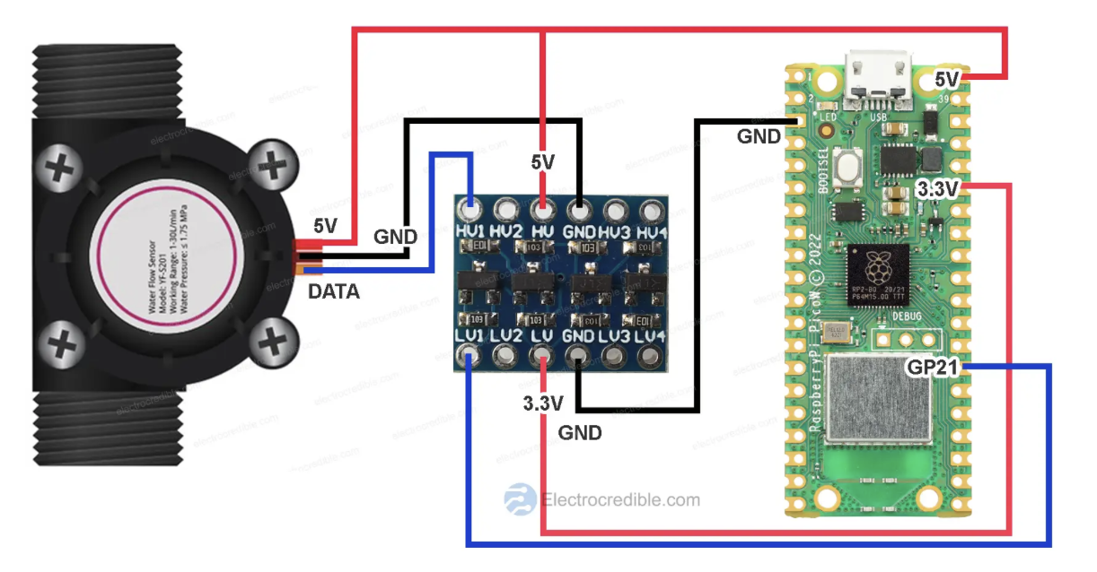

* Refer the raspberry pi pico W pinout diagram [here](https://datasheets.raspberrypi.com/picow/PicoW-A4-Pinout.pdf)
* Flow Rate calculations: [Refer](https://electrocredible.com/raspberry-pi-pico-flow-sensor-yfs201/)
$Flow rate (L/min)=Frequency (Hz) / 7.5$

* Connecting OLED to PICO

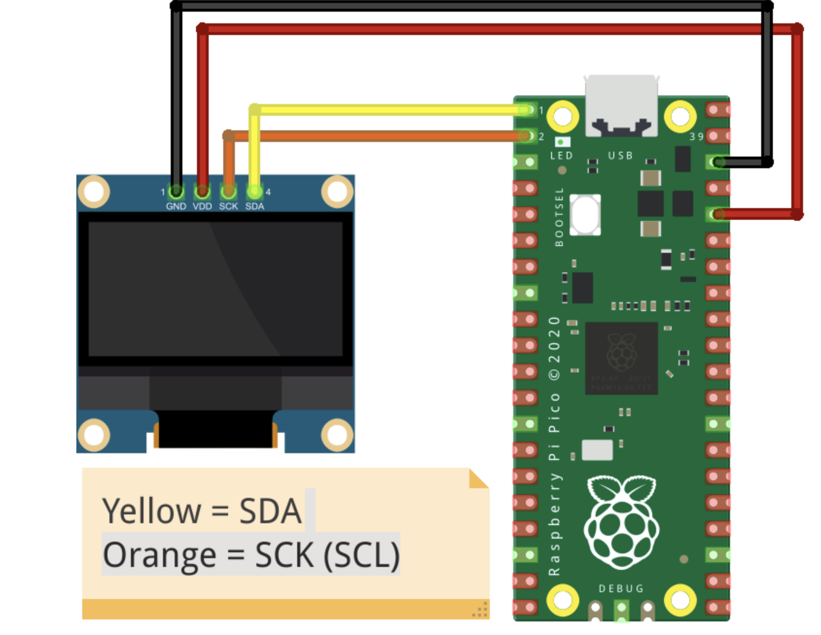

* Picture of the connections (Final result)

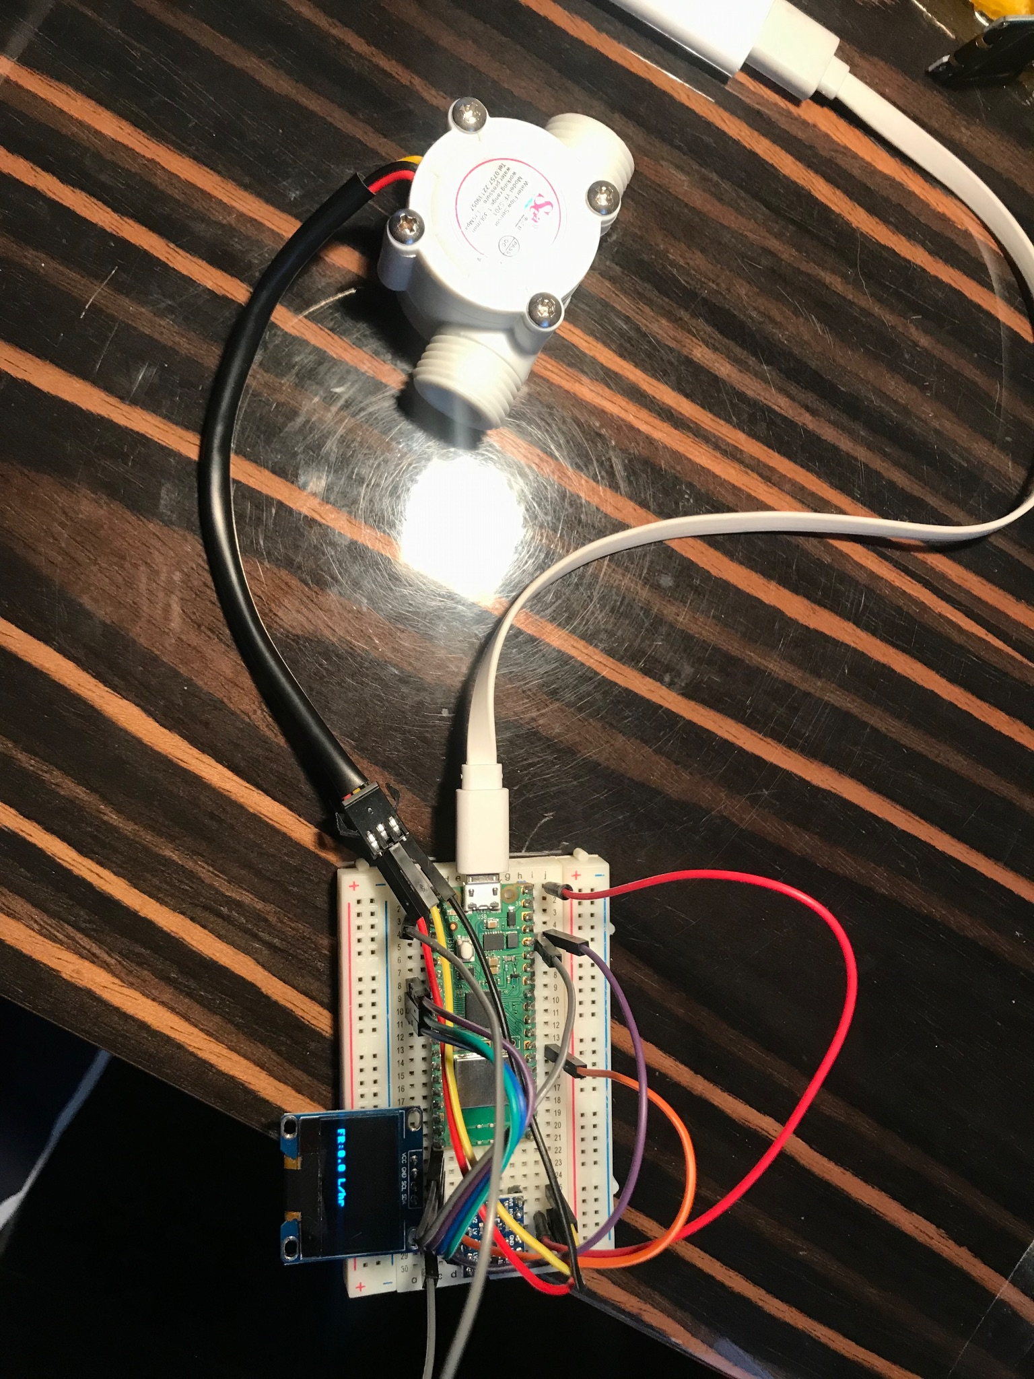

### Code:

* I will be using python in [Thonny](https://thonny.org) IDE to program the picoW
* [Setup the picoW to be used with thonny](https://projects.raspberrypi.org/en/projects/getting-started-with-the-pico/2)
* Code to output the flow rate and output

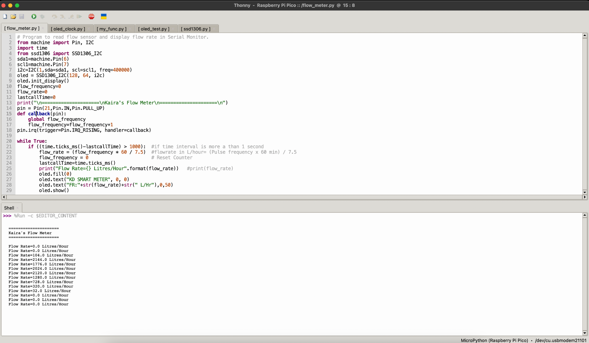

* Code to send the flow rate to the Local Server :

<Work in Progress>

### Output:

* Note: Output data simulated by blowing air through the flow sensor, it should be similar to flow of water at the same rate.

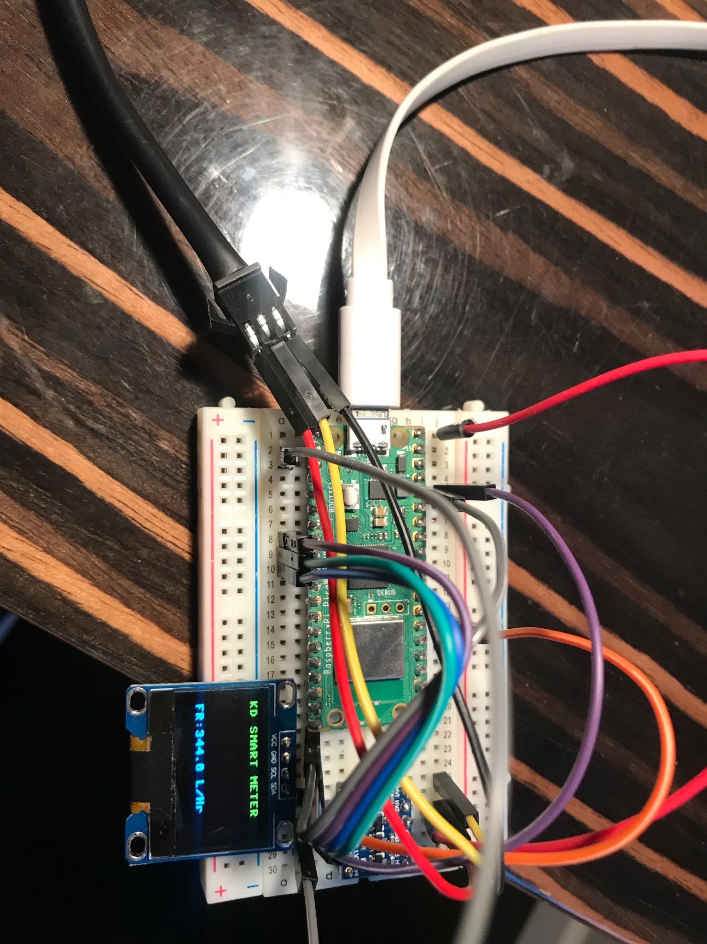

### Interfacing the microcontroller and Mobile App

### 

### 

### References:

<https://electrocredible.com/raspberry-pi-pico-flow-sensor-yfs201/>